Ubuntu Installation (Windows version)

- You must have windows 10 and updated.
- Open Microsoft Store from the start.
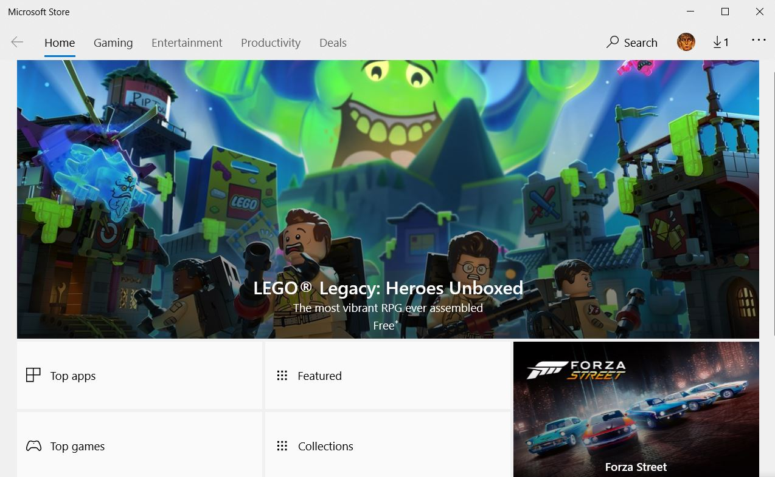
- In the search field, type “ubuntu” and select ubuntu 18.04 Lite. After installing it proceed to step 4.

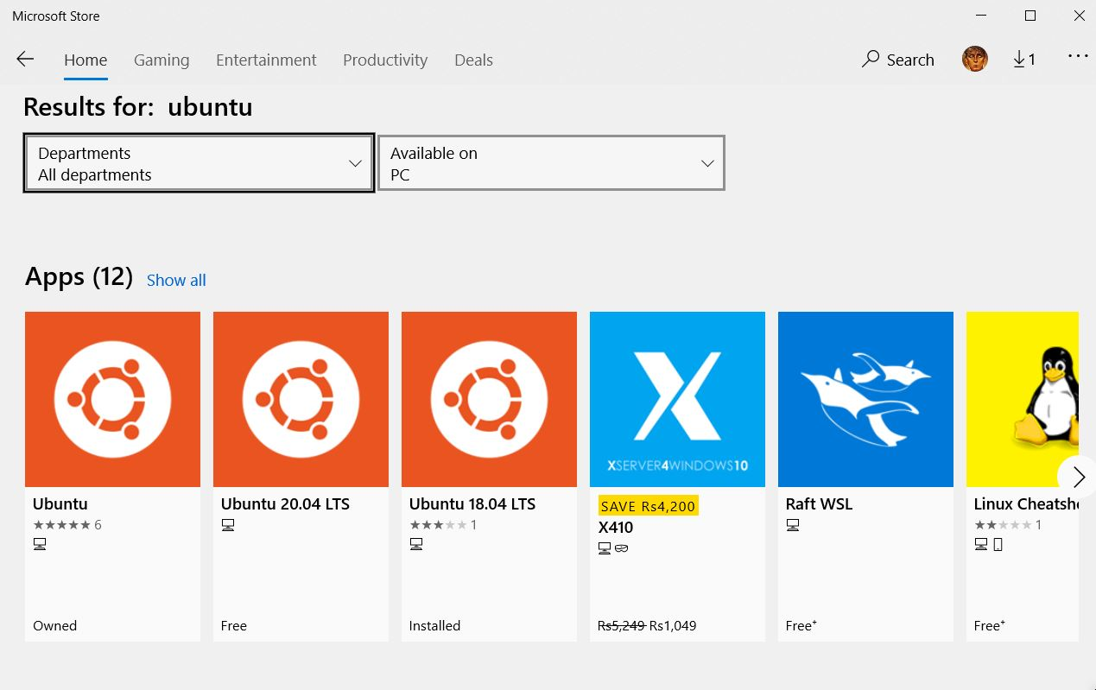

- Now go back to start and choose “settings”.

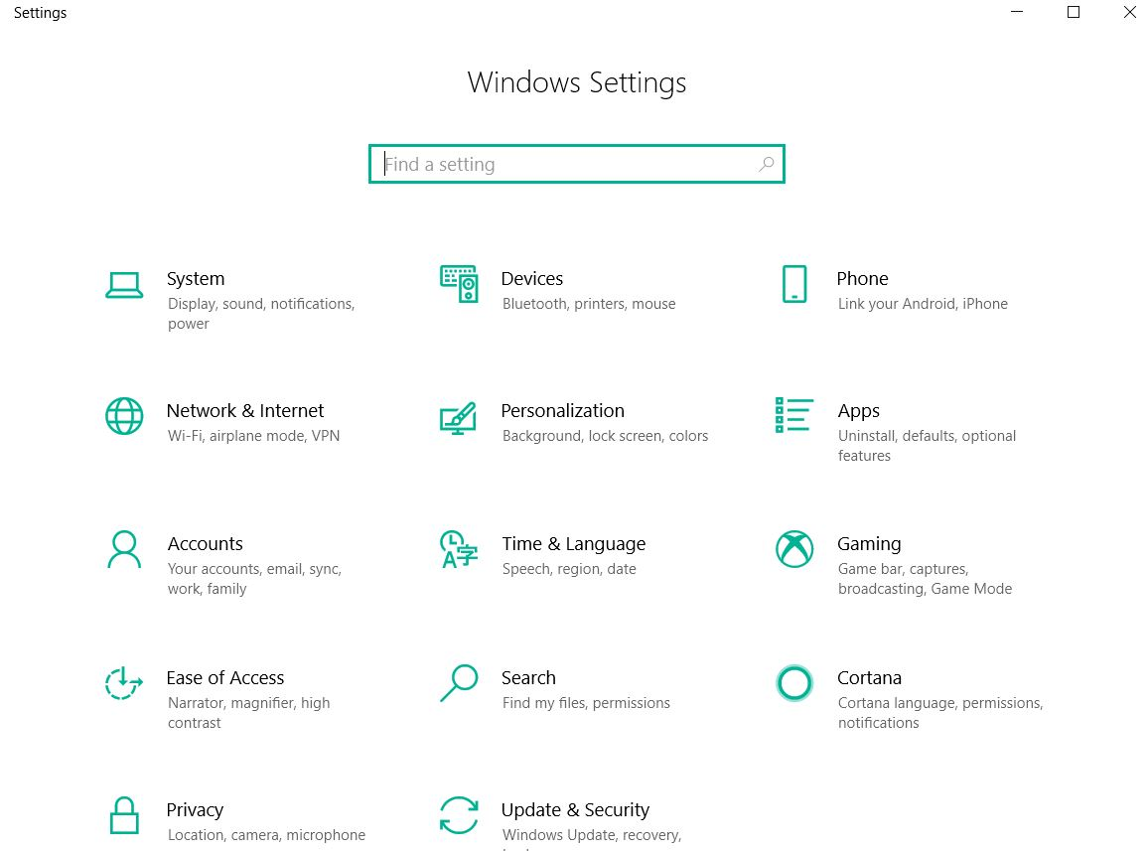
- In the settings click on “Update & Security”.
- From the left pane select “For Developers”. In this check the “Developer Mode” circle.
- Wait for a bit, while all the necessary packages are downloaded.
- After all the packages are downloaded click on the start again and type “Turn Windows Features On & Off”.
- In this new window, scroll down to check the box “Windows Subsystem for Linux”.

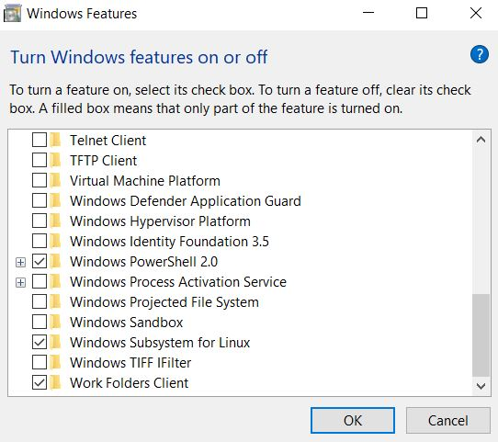

- Wait for a bit here too, while all the necessary files are downloaded.
- After this you will be prompt to restart your PC. Restart!
- After you have successfully rebooted your PC, turn on Ubuntu 18.04 Lite from the Microsoft Store by pressing the launch icon.
- Here you will be asked for username and password.
- Choose username and password such that all letters must be small, short and without spaces.
- After you have successfully set the username and password, type in following command: sudo apt-get install build-essential
- Remember to press “TAB” after this command and then press enter.
- Resolve errors if any and run the same command in step 15 &16 again.
- Wait a bit here too, while all the packages are installed properly.
- Your Ubuntu is ready to work. You might want to navigate to your drives e.g. c, d, e etc. To do so experiment with “cd ..” and “ls” commands and find a file called “mnt”. Inside it you will find all your drives.
- Enjoy.

